

6/9/2017

Rose, Hyeon, Tristan, Min Woo, Brian

Southern Institute of Technology

Assignment 2

Tourism Agency

Table of Contents

Business Rules 1

Database Model 2

Data Dictionary 3

Database Design 12

Tables 12

Forms 17

Reports 20

Main Menu 22

Schedules 23

Gantt 23

PERT 25

System Implementation 26

Testing/Evaluation Checklist 26

Usability Testing Results 27

Screenshots of final system 28

Main menu 28

Forms 30

Reports 33

Executive Summary 39

Conclusion 39

Appendices 40

Appendix A 40

Glossary of terms 41

References 42

Table of figures

**Figure 1: Database Model of Tourism Agency** 2

**Figure 2: Table of Customer** 3

**Figure 3:Table of Staff** 4

**Figure 4: Booking Table** 5

**Figure 5: Address Table** 6

**Figure 6: Postcode Table** 6

**Figure 7:Position Table** 7

**Figure 8:Payment Table** 7

**Figure 9: Agency Table** 8

**Figure 10: Flight Table** 8

**Figure 11:Airline Route Table** 9

**Figure 12:Airport Table** 9

**Figure 13: Room Table** 10

**Figure 14:Hotel Table** 10

**Figure 15:Room Type Table** 11

**Figure 16 Customer Table Validation Rule Set Up** 12

**Figure 17 : Customer Table with Input Mask** 13

**Figure 18 :Booking Table with Default Value** 14

**Figure 19: Customer Table with Format** 15

**Figure 20: Table Position with format changing** 16

**Figure 21: Form of staff login which staff can check and manage the database.** 17

**Figure 22: Form that customer can book a room.** 18

**Figure 23: Flight booking form which customer can book a flight** 19

**Figure 24: Monthly Flight Booking Report** 20

**Figure 25: Sale of Staff Report** 21

**Figure 26: Main menu** 22

**Figure 27:Schedule** 23

**Figure 28:Gantt Chart** 24

**Figure 29:PERT chart** 25

**Figure 30: Tri's testing** 27

**Figure 31 :Joe's testing** 27

**Figure 32:Marvin's testing** 28

**Figure 33:Main menu** 28

**Figure 34: Customer login** 29

**Figure 35: Staff login** 29

**Figure 36:Flight Booking Form** 30

**Figure 37:Room Booking Form** 31

**Figure 38:Staff can book can by this form** 31

**Figure 39:Database Form** 32

**Figure 40: Monthly Room Booking Report** 33

**Figure 41:Monthly Flight Booking Report** 34

**Figure 42: Sales Report** 35

**Figure 43:Flight Booking Report** 36

**Figure 44:Sale of Staff Report** 37

**Figure 45: Room Booking Report** 38

# Business Rules

1. Every **payment** may have many **bookings**
2. Many **bookings** must have one **payment**
3. Every **address** must have one **postcode.**
4. Each **postcode** may have many **address**
5. The **customer** must own one **address.**
6. Every **address** may have many **customers**
7. The **staff** must own one **address.**
8. Every **address** may be owned by many **staffs**
9. The **agency** may hire many **staffs**
10. Many **staffs** must be hired by one **agency**
11. Every **staff** must in charge of one **position**.
12. Every **position** may belong to many **staffs.**
13. Each **customer** may have many **bookings**
14. Each **booking** must be created by one and only one **customer**.
15. Each **staff** may manage may **bookings**.
16. Each **booking** must be managed by one **staff.**
17. Each **flight** may have many **bookings**.
18. Each **booking** must have only one **flight.**
19. Each **room** may have many **bookings**
20. Each **booking** must have one **room.**
21. Each **flight** must be scheduled by one **airline route**.
22. Each **airline route** may have many **flights**.
23. Each **airline route** must be defined by one **airport.**
24. Each **airport** may have many **airline routes.**
25. Each **hotel** may have many **rooms**
26. Each **room** must belong to one **hotel**.
27. Each **room** must have one **room type**.
28. Each **room type** may belong to **many rooms**.

# Database Model

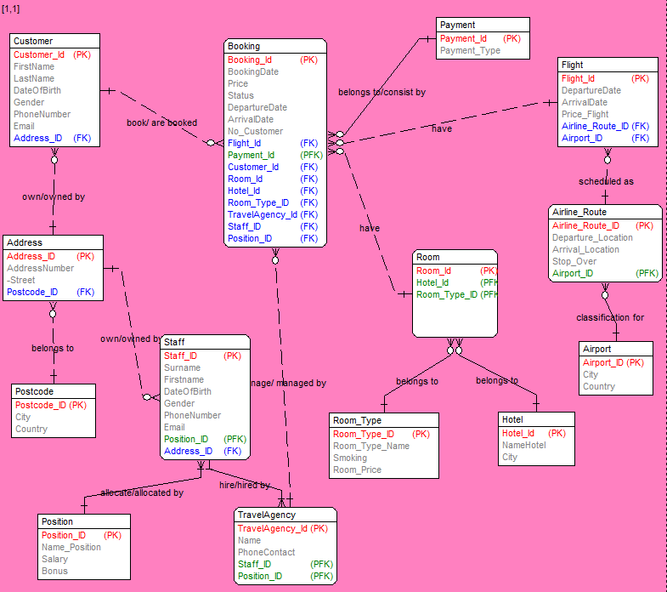ERD

**Figure 1: Database Model of Tourism Agency**

# Data Dictionary

|  |  |  |  |  |  |  |  |
| --- | --- | --- | --- | --- | --- | --- | --- |
| TABLE NAME | ATTRIBUTE NAME | CONTENTS | TYPE | FORMAT | REQUIRED | PK/FK | FK REFERENCED TABLE |
| **Customer** | Customer_Id | Customer ID | Integer |  | Yes | PK |  |
| FirstName | Customer First Name | Text(30) |  | Yes |  |  |
| LastName | Customer Last Name | Text(30 |  | Yes |  |  |
| DateOfBirth | Customer Date of Birth | Date/Time | Medium Date | No |  |  |
| Gender | Customer Gender | Text(30) |  | No |  |  |
| Phonenumber | Customer phone number | Text(50) | 999-9999-999 | No |  |  |
| Email | Customer Email | Text(30) |  | No |  |  |
| Address_ID | Customer Address ID | Text(255) |  | No | FK | Address |

**Figure 2: Table of Customer**

|  |  |  |  |  |  |  |  |
| --- | --- | --- | --- | --- | --- | --- | --- |
| TABLE NAME | ATTRIBUTE NAME | CONTENTS | TYPE | FORMAT | REQUIRED | PK/FK | FK REFERENCED TABLE |
| **Staff** | Staff_Id | Staff ID | Integer |  | Yes | PK |  |
| FirstName | Staff First Name | Text(50) |  | Yes |  |  |
| LastName | Staff Last Name | Text(50) |  | Yes |  |  |
| DateOfBirth | Staff Date of Birth | Date/Time | Medium Date | No |  |  |
| Gender | Staff Gender | Text(50) |  | No |  |  |
| Phonenumber | Staff phone number | Text(50) | 999-9999-999; | No |  |  |
| Email | Staff Email | Text(30) |  | No |  |  |
| Address_ID | Staff Address ID | Text(255) |  | No | FK | Address |
| Position_ID | Staff position ID |  |  | No | FK | Position |

**Figure 3:Table of Staff**

|  |  |  |  |  |  |  |  |
| --- | --- | --- | --- | --- | --- | --- | --- |
| TABLE NAME | ATTRIBUTE NAME | CONTENTS | TYPE | FORMAT | REQUIRED | PK/FK | FK REFERENCED TABLE |
| **Booking** | Boking_Id | Booking ID | Integer |  | Yes | PK |  |
| DateOfBooking | Date of Booking | Date/Time | Medium Date | Yes |  |  |
| Customer_Id | Customer ID | Text(50) |  | No | FK | Customer |
| Flight_Id | Flight ID | Text(50) |  | No | FK | Flight |
| Agency_Id | Agency ID | Text(50) |  | No | FK | Agency |
| Room_Id | Room ID | Text(50) |  | No | FK | Room |
| No_People_Flight | Number of people using flight | Number | Long integer |  |  |  |
| PaymentID | Payment ID | Text(255) |  | No | FK | Payment |
| Cost | Cost | Currency |  | No |  |  |

**Figure 4: Booking Table**

|  |  |  |  |  |  |  |  |
| --- | --- | --- | --- | --- | --- | --- | --- |
| TABLE NAME | ATTRIBUTE NAME | CONTENTS | TYPE | FORMAT | REQUIRED | PK/FK | FK REFERENCED TABLE |
| **Address** | Address_Id | Address ID | Integer |  | Yes | PK |  |
| AddressNumber | Address number | Text(50) |  | Yes |  |  |
| Street | Address street | Text(50) |  | Yes |  |  |
| Postcode | Address Postcode | Text(50) |  | No |  |  |

**Figure 5: Address Table**

|  |  |  |  |  |  |  |  |
| --- | --- | --- | --- | --- | --- | --- | --- |
| TABLE NAME | ATTRIBUTE NAME | CONTENTS | TYPE | FORMAT | REQUIRED | PK/FK | FK REFERENCED TABLE |
| **Postcode** | Postcode_Id | Postcode ID | Integer |  | Yes | PK |  |
| City | Postcode city | Text(50) |  | Yes |  |  |
| Country | Postcode Country | Text(50) |  | Yes |  |  |

**Figure 6: Postcode Table**

|  |  |  |  |  |  |  |  |
| --- | --- | --- | --- | --- | --- | --- | --- |
| TABLE NAME | ATTRIBUTE NAME | CONTENTS | TYPE | FORMAT | REQUIRED | PK/FK | FK REFERENCED TABLE |
| **Position** | Position_ID | Position ID | Integer |  | Yes | PK |  |
| Name_Position | Name of position | Text(50) |  | Yes |  |  |
| Salary | Position salary | Currency | $###,##0.00 | Yes |  |  |
| Bonus | Position Bonus | Number | ###.00% | Yes |  |  |

**Figure 7:Position Table**

|  |  |  |  |  |  |  |  |
| --- | --- | --- | --- | --- | --- | --- | --- |
| TABLE NAME | ATTRIBUTE NAME | CONTENTS | TYPE | FORMAT | REQUIRED | PK/FK | FK REFERENCED TABLE |
| **Payment** | Payment_Id | Payment ID | Integer |  | Yes | PK |  |
| PaymentName | Payment Name | Text(50) |  | Yes |  |  |

**Figure 8:Payment Table**

|  |  |  |  |  |  |  |  |
| --- | --- | --- | --- | --- | --- | --- | --- |
| TABLE NAME | ATTRIBUTE NAME | CONTENTS | TYPE | FORMAT | REQUIRED | PK/FK | FK REFERENCED TABLE |
| **Agency** | Agency_Id | Agency ID | Integer |  | Yes | PK |  |
| AgencyName | Agency name | Text(50) |  | Yes |  |  |
| StaffID | Staff ID | Text(50) |  | Yes | FK | Staff |
| PhoneContact | Agency phone contact | Text(50) |  |  |  |  |

**Figure 9: Agency Table**

|  |  |  |  |  |  |  |  |
| --- | --- | --- | --- | --- | --- | --- | --- |
| TABLE NAME | ATTRIBUTE NAME | CONTENTS | TYPE | FORMAT | REQUIRED | PK/FK | FK REFERENCED TABLE |
| **Flight** | Flight_Id | Flight ID | Integer |  | Yes | PK |  |
| DepartureDate | Departure Date of Flight | Date/Time | Medium Time |  |  |  |
| ArrivaDate | Arrival Date of Flight | Date/Time | Medium Time |  |  |  |
| Flight_Route_Id | Agency phone contact | Text(50) |  |  | FK | Flight_Route |
| Price | Flight Price | Currency |  |  |  |  |

**Figure 10: Flight Table**

|  |  |  |  |  |  |  |  |
| --- | --- | --- | --- | --- | --- | --- | --- |
| TABLE NAME | ATTRIBUTE NAME | CONTENTS | TYPE | FORMAT | REQUIRED | PK/FK | FK REFERENCED TABLE |
| **Airline_Route** | Flight_Route_Id | Flight Route Id | Integer |  | Yes | PK |  |
| Departure_Location | Departure Location | Text(250) |  |  |  |  |
| Arrival_Location | Arrival Location | Text(50) |  |  |  |  |
| Stopover | Stop Over | Text(50) |  |  |  |  |

**Figure 11:Airline Route Table**

|  |  |  |  |  |  |  |  |
| --- | --- | --- | --- | --- | --- | --- | --- |
| TABLE NAME | ATTRIBUTE NAME | CONTENTS | TYPE | FORMAT | REQUIRED | PK/FK | FK REFERENCED TABLE |
| **Airport** | Airport_Id | Airport ID | Integer |  | Yes | PK |  |
| City | Airport City | Text(50) |  | Yes |  |  |
| Country | Airport Country | Text(50) |  | Yes |  |  |

**Figure 12:Airport Table**

|  |  |  |  |  |  |  |  |
| --- | --- | --- | --- | --- | --- | --- | --- |
| TABLE NAME | ATTRIBUTE NAME | CONTENTS | TYPE | FORMAT | REQUIRED | PK/FK | FK REFERENCED TABLE |
| **Room** | Room_Id | Room ID | Integer |  | Yes | PK |  |
| Hotel_Id | Hotel ID | Text(50) |  |  | FK | Hotel |
| RoomType_Id | Hotel Room Type ID | Text(50) |  |  | FK | Room_Type |

**Figure 13: Room Table**

|  |  |  |  |  |  |  |  |
| --- | --- | --- | --- | --- | --- | --- | --- |
| TABLE NAME | ATTRIBUTE NAME | CONTENTS | TYPE | FORMAT | REQUIRED | PK/FK | FK REFERENCED TABLE |
| **Hotel** | Hotel_Id | Hotel ID | Integer |  | Yes | PK |  |
| HotelName | Hotel Name | Text(50) |  | Yes |  |  |
| City | Hotel City | Text(50) |  | Yes |  |  |

**Figure 14:Hotel Table**

|  |  |  |  |  |  |  |  |
| --- | --- | --- | --- | --- | --- | --- | --- |
| TABLE NAME | ATTRIBUTE NAME | CONTENTS | TYPE | FORMAT | REQUIRED | PK/FK | FK REFERENCED TABLE |
| **Room_Type** | Room_Type_Id | Room_Type ID | Integer |  | Yes | PK |  |
| RoomType | Room Type | Text(50) |  | Yes |  |  |
| Smoking | Smoking | Yes/No |  | Yes |  |  |
| Room_Price | Room Price | Currency |  | Yes |  |  |

**Figure 15:Room Type Table**

# Database Design

## Tables

**Figure 16 Customer Table Validation Rule Set Up**

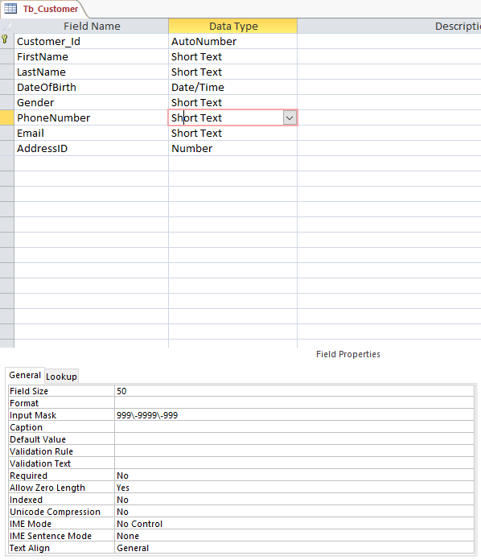

**Figure 17 : Customer Table with Input Mask**

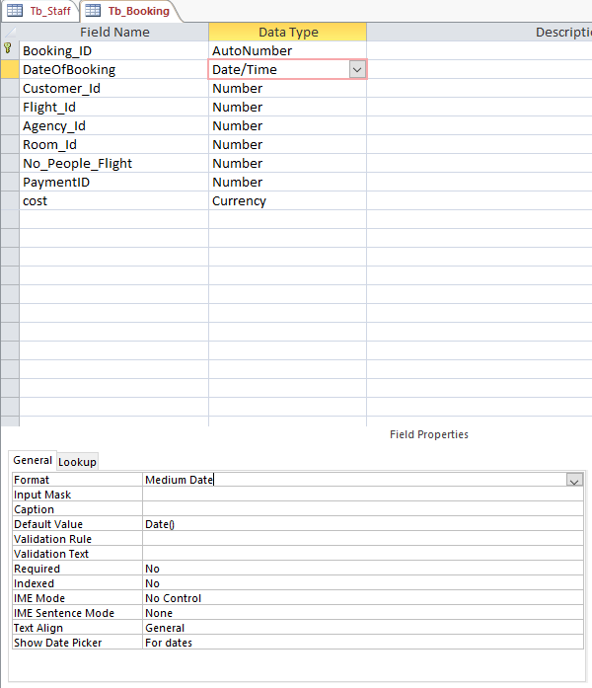

**Figure 18 :Booking Table with Default Value**

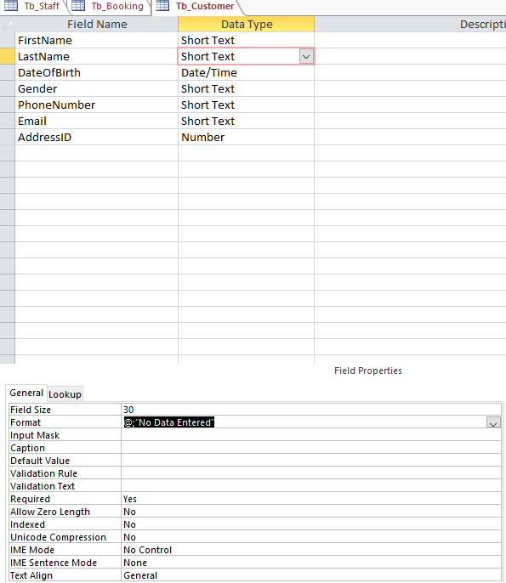

**Figure 19: Customer Table with Format**

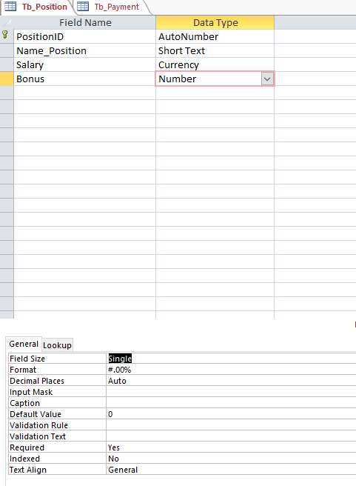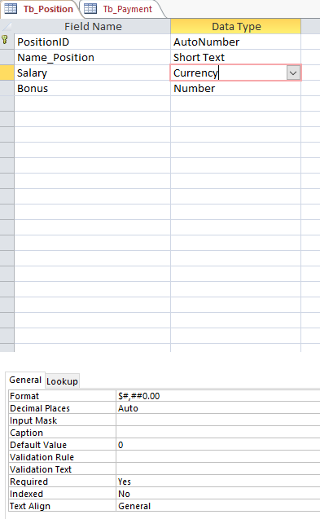

**Figure 20: Table Position with format changing**

## Forms

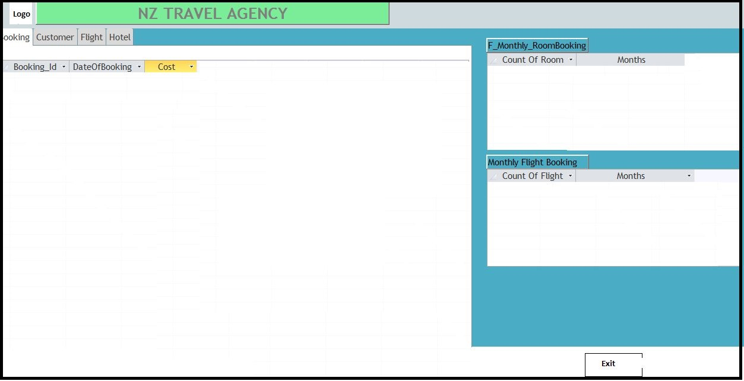

**Figure 21: Form of staff login which staff can check and manage the database.**

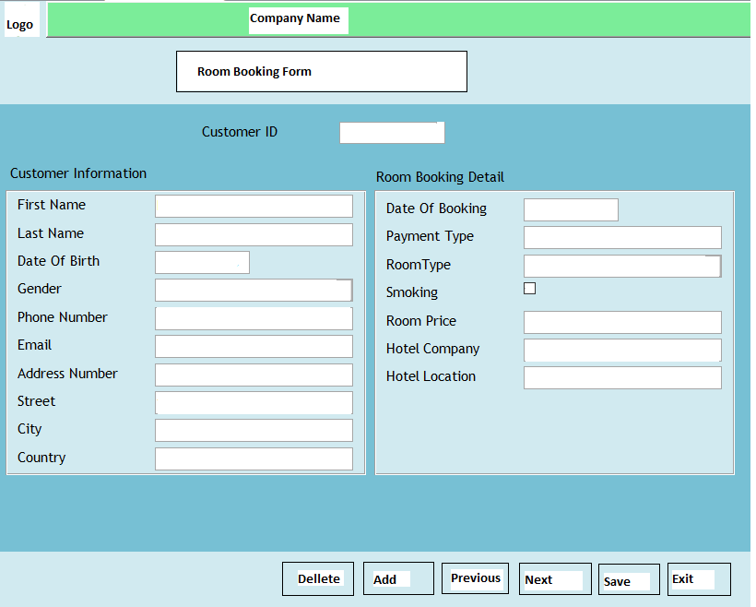

**Figure 22: Form that customer can book a room.**

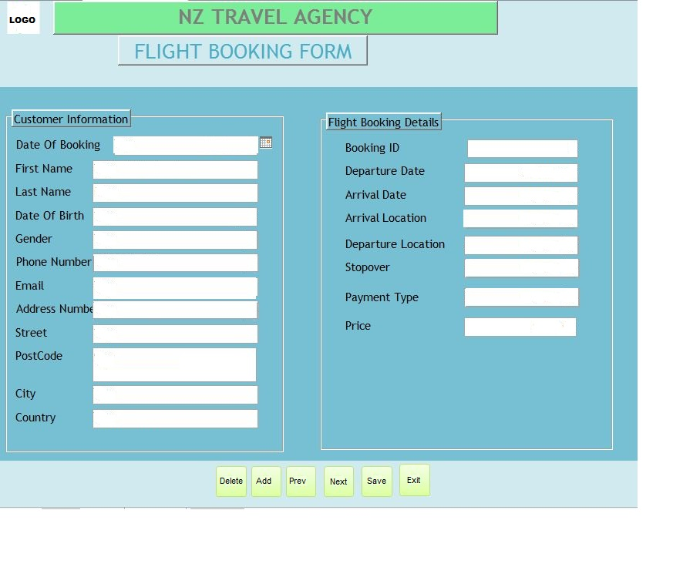

**Figure 23: Flight booking form which customer can book a flight**

## Reports

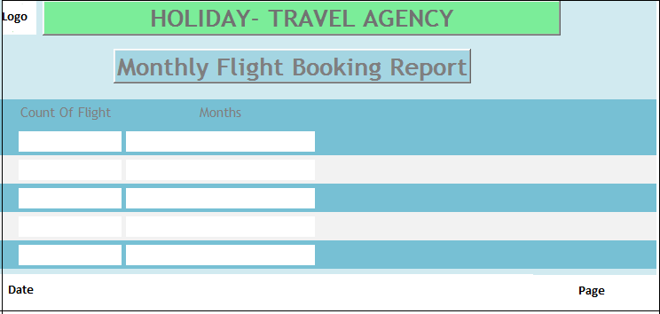

**Figure 24: Monthly Flight Booking Report**

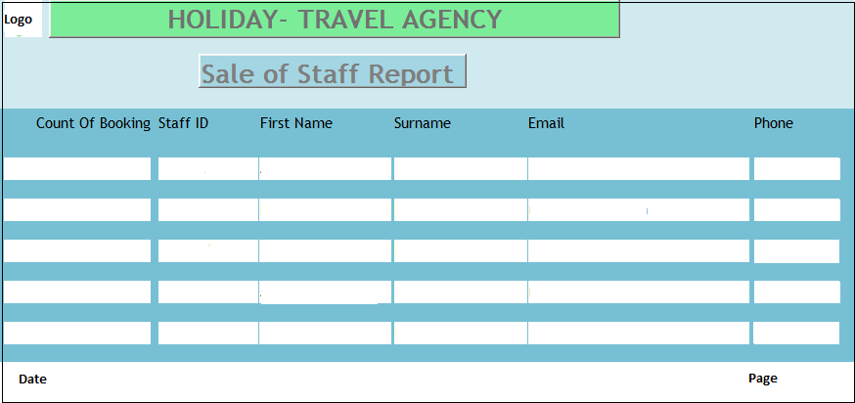

**Figure 25: Sale of Staff Report**

## Main Menu

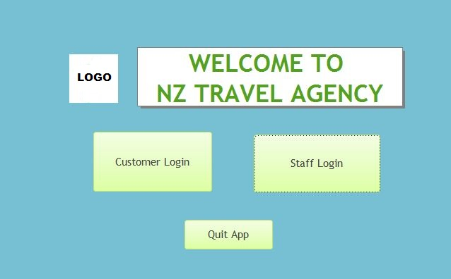

**Figure 26: Main menu**

# Schedules

## Gantt

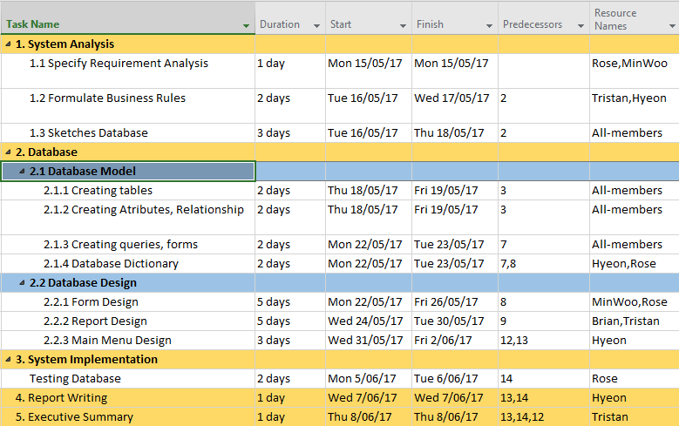

**Figure 27:Schedule**

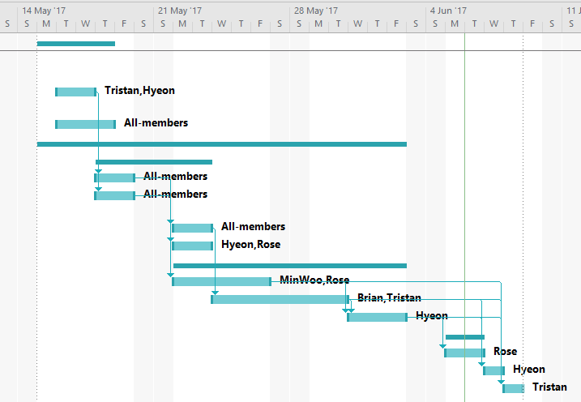

**Figure 28:Gantt Chart**

PERT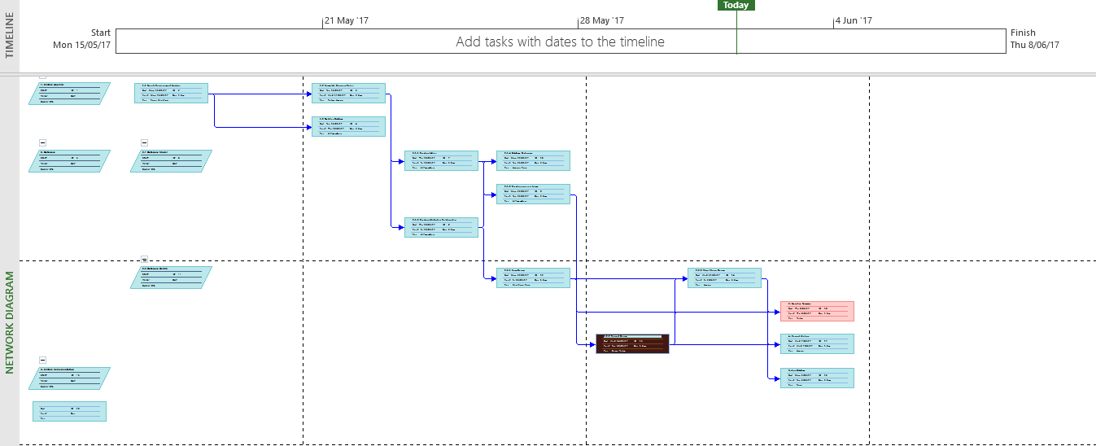

**Figure 29:PERT chart**

# System Implementation

## Testing/Evaluation Checklist

(Database Testing Checklist, 2016)

**Test plan**

**Purpose**

This project that we created will have some function for customer booking and staff management. So we plan to test all section of all the form such as flight booking, room booking, and staff can check, modify the data into the database system. After testing, we will find out what is the problem and solve it to improving our system.

**Object Test (All Pass)**

* For all button of function from forms like add new record, delete, save, next, previous and exit whether it work or not.
* Whether the customer can book a flight and a room or not.
* Whether the staff can modify, check and restore the data or not
* How impressive of the first time to see our database system
* The data can be modified, stored or exported
* To ensure that the data types are being placed correctly in tables
* To ensure the appropriate and sufficient length of each field to import and accommodate respective data value of varying range.
* To check whether all identical fields have similar name throughout the database and tables.
* To check whether all identical fields have similar name throughout the database and tables.
* Whether the primary key and the foreign key constraints is specified and created for each table or not.
* To ensure that the data is being committed on the successful execution of the transaction.
* Database performance in terms of time taken, for the execution of lesser number of queries for small set of records.
* Database performance in terms of time taken, for the execution of queries pertaining to comparatively large set of records.

In conclusion: we have some problems but we did fix all of things.

## Usability Testing Results

Marvin Team

Marvin team did look about our databases and they find that could not work some functions.

Tri

|  |  |  |  |
| --- | --- | --- | --- |
| Form/Report  Name | Description of Component/ Interaction Problem & Solution | Heuristic(s) #Violated | Severity |
| F_FlightBooking | **Problem**: Add new booking could not work, all field are empty.  **Solution**: modified the queries | 1 | 4 |
| Main menu | **Problem:** the open form of customer did not work.  **Solution:** Delete the open button and create a new one. | 1 | 1 |

See Appendix A

**Figure 30: Tri's testing**

Joe

|  |  |  |  |
| --- | --- | --- | --- |
| Form/Report  Name | Description of Component/ Interaction Problem & Solution | Heuristic(s) #Violated | Severity |
| T_Customer | **Problem**: the phone number is hard to read  **Solution**: change the format into 999-9999-999 | 1 | 1 |
| Main menu | **Problem:** the open form of customer did not work.  **Solution:** Delete the open button and create a new one. | 1 | 1 |
| T_Position | Problem: The currency field did not have $ symbol automatically.  Solution: change the format into $###,##0.00 | 1 | 1 |
| T_Position | Problem: The bonus field did not have % symbol automatically.  Solution: change the format into ###.00% | 1 | 1 |

See Appendix A

**Figure 31 :Joe's testing**

Marvin

|  |  |  |  |
| --- | --- | --- | --- |
| Form/Report  Name | Description of Component/ Interaction Problem & Solution | Heuristic(s) #Violated | Severity |
| Main menu | **Problem**: the reports could not open from the main menu form.  **Solution**: add the button to open reports | 1 | 2 |
| F_Booking | **Problem:** the date of birth requires between 1 and 100 age.  **Solution:** have to calculate the date, so we change the validate rule into > 01/01/2017 | 1 | 2 |

See Appendix A

**Figure 32:Marvin's testing**

## Screenshots of final system

### Main menu

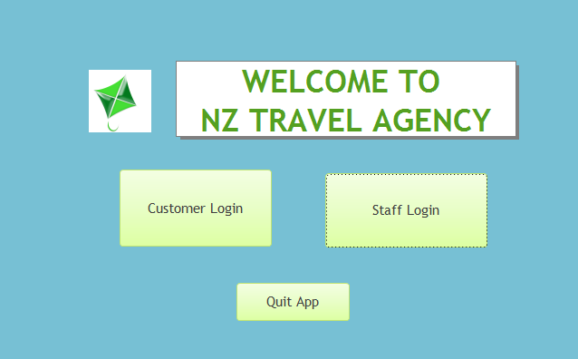

**Figure 33:Main menu**

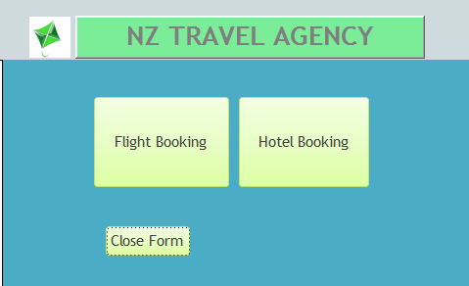

**Figure 34: Customer login**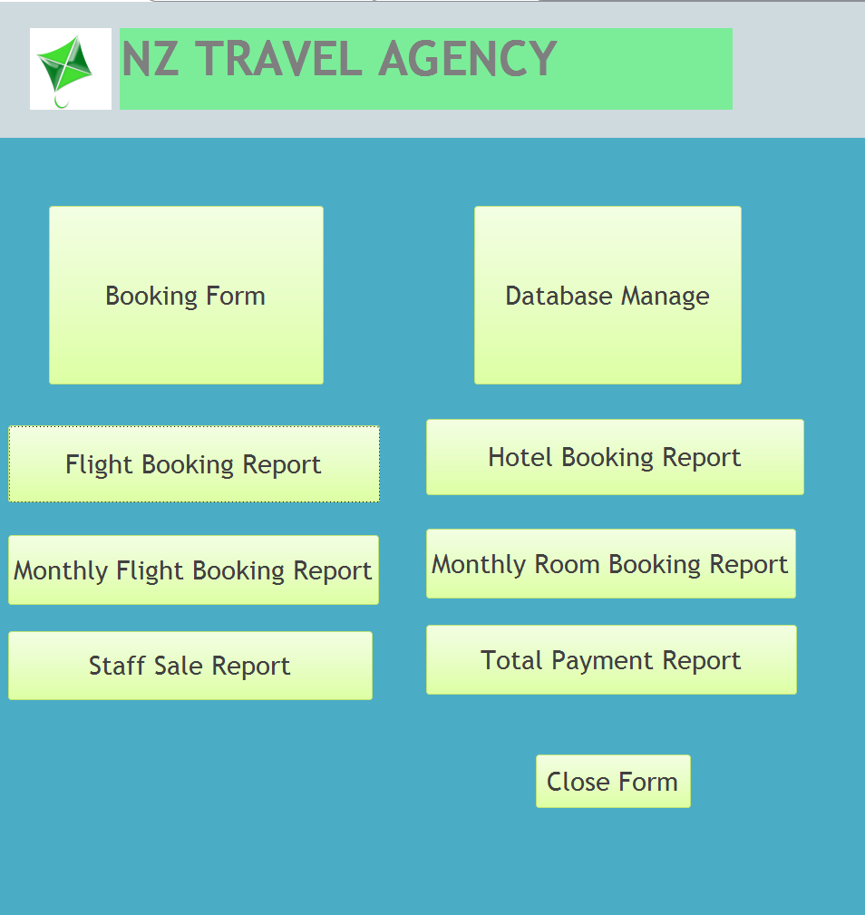

**Figure 35: Staff login**

### Forms

**Figure 36:Flight Booking Form**

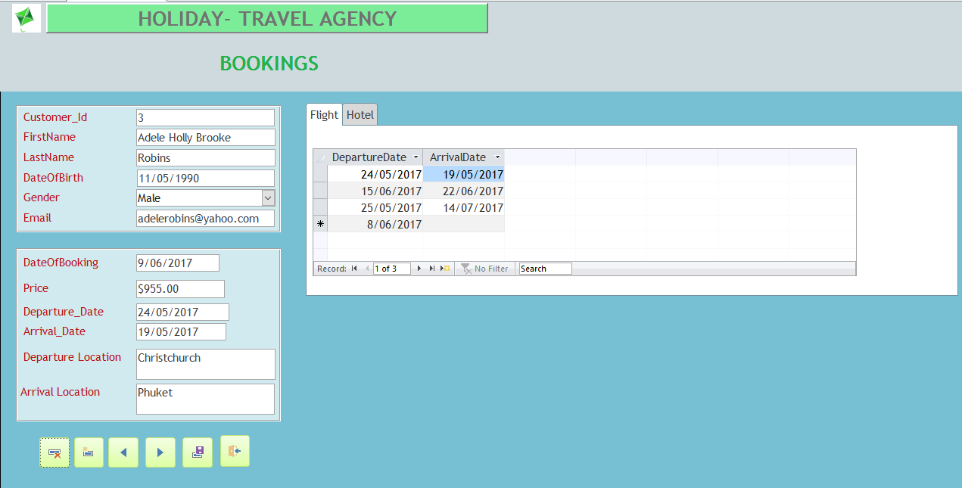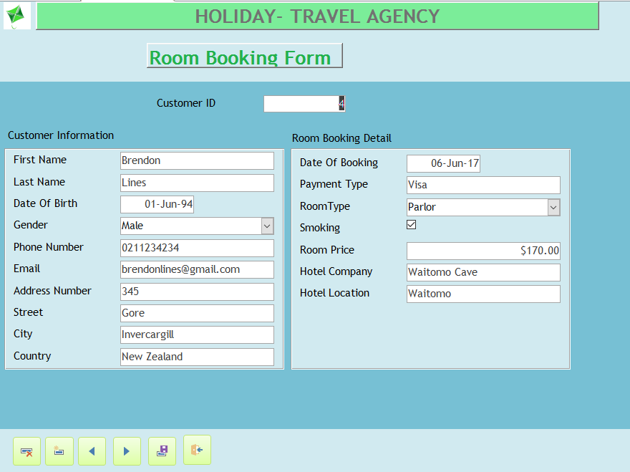

**Figure 37:Room Booking Form**

**Figure 38:Staff can book can by this form**

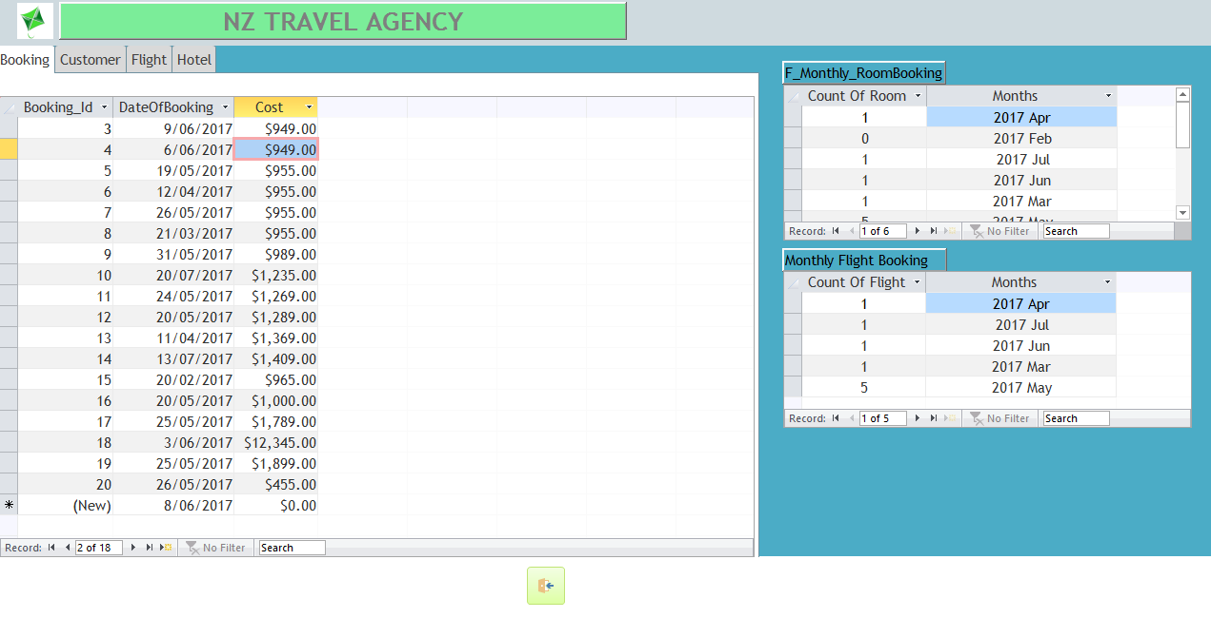

**Figure 39:Database Form**

### Reports

**Figure 40: Monthly Room Booking Report**

**Figure 41:Monthly Flight Booking Report**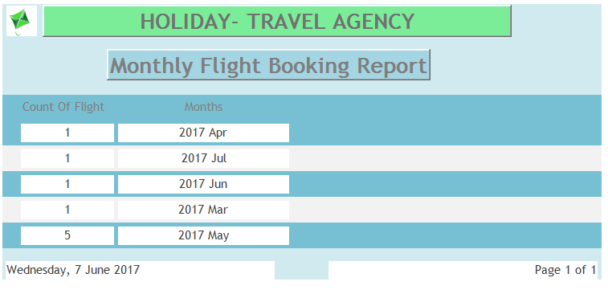

**Figure 42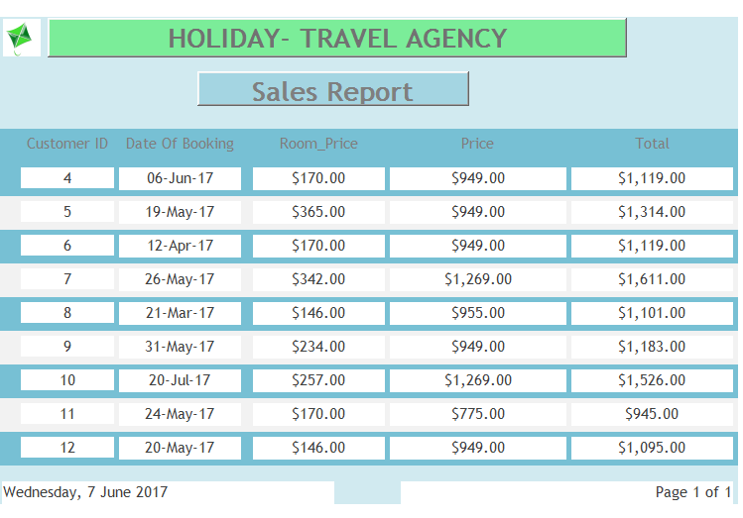: Sales Report**

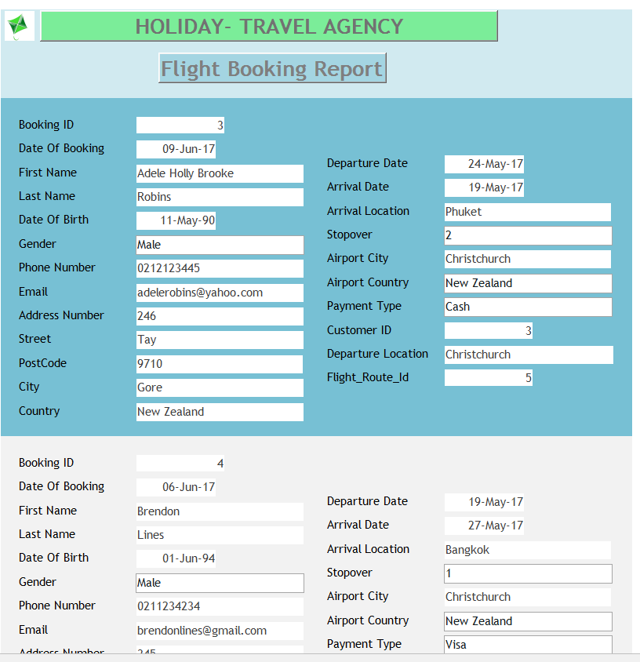

**Figure 43:Flight Booking Report**

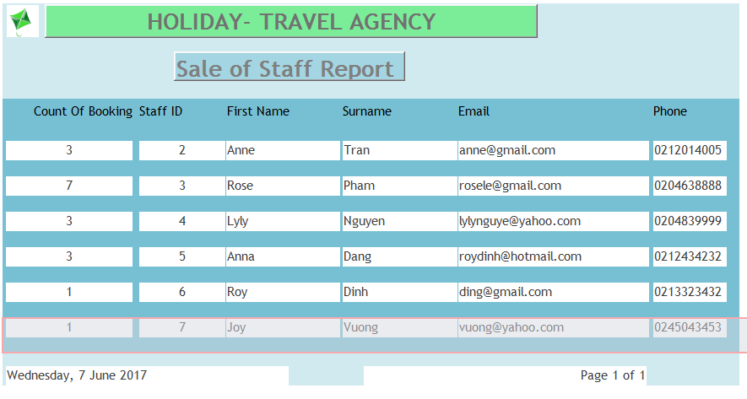

**Figure 44:Sale of Staff Report**

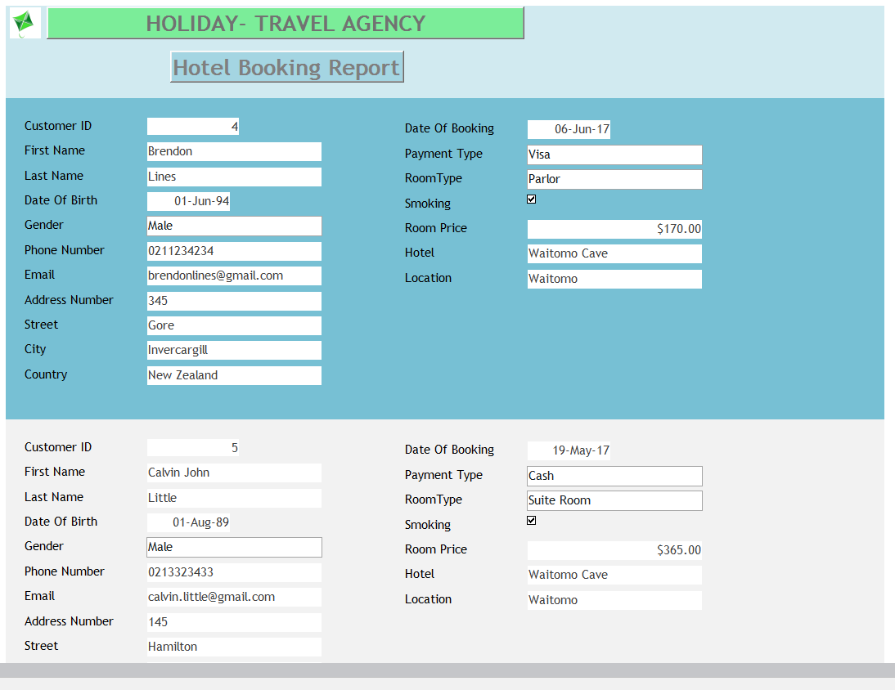

**Figure 45: Room Booking Report**

# Executive Summary

Through this project our team members have learned a lot of thing about software development and design. In particularly, we know how to analyse the business rules which are the nature of business and help us how to understand what is entity and attribute to design a database model from Toad.

Besides that, the tutor has taught us the basic software from access software which we have learned how to create database including tables, queries, forms and reports, which all have different functions. Before doing the queries or other tasks, the most important thing is that the relationship should defined clearly, therefore the flow of database will work smoothly.

On the other hand, what we learn is how to design forms and reports in professional way from the property sheet or set up the format, input mask, validation rule and so on, those things helped us to create our database for tourism agency with many functional forms that suitable for this project.

# Conclusion

The ideas of our team have been built to meet the needs of potential customer in tourism agency. We create two type of database accesses including customer login and staff login, so the database with help the tourism agency manages the business effectively. On the one hand, the customer can access and booking the services from agency such as flight booking and room booking. On the other hand, the staff can check, add, modify, delete or save the data as well as manage the database system effectively. In addition, from the queries we can count how many booking that the staffs have been sold, or the agency can check how many booking today and monthly. So it allows the admin of agency monitor the sales of the business, from that the agency will know how to run a business in effective way. The benefits of report improve restoring the data of the company, so the agency can save the cost of management.

# Appendices

## Appendix A

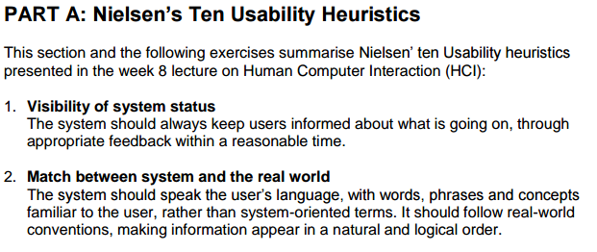

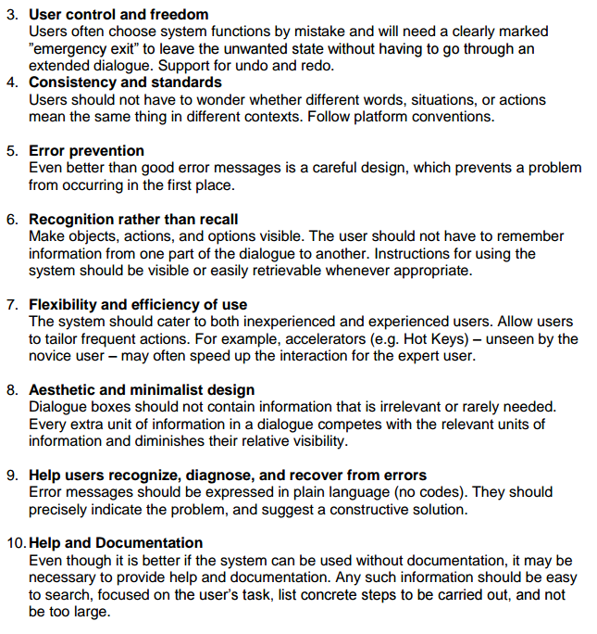

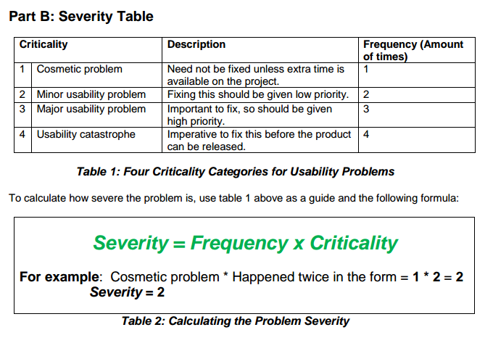

# Glossary of terms

PF

Primary Key

FK

Foreign key

# References

Beal, V. (n.d.). *Entity-relationship diagram (model)*. Retrieved from http://www.webopedia.com: http://www.webopedia.com/TERM/E/entity_relationship_diagram.html

*Database Testing Checklist*. (2016, September). Retrieved from http://www.professionalqa.com: http://www.professionalqa.com/database-testing-checklist